7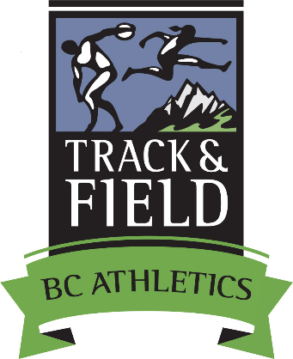

2017 BC Athletics Summer Student Employment Opportunity
Track & Field Program Assistant
(Supported by: The Canada Summer Jobs Program - Government of Canada and BC Athletics)

Job Position: Track & Field Program Assistant

Estimated Length of Employment: 14 to 15 weeks
Starting Date: Monday, May 22, 2017 Ending Date: Friday, August 25 or Friday, September 1, 2017

Application Deadline: Monday, May 15, 2017 – 4:00pm.

Program (Federal Govt) requirements for all applicants:
- be between 15 and 30 years of age at the start of the employment;
- have been registered as a full-time post-secondary student in the academic year (2016/17) and intending to
enroll or return to post-secondary school on a full-time basis in the next academic year (2017/18);
- be a Canadian citizen, permanent resident or persons on whom refugee protection has been conferred under
the Immigration and Refugee Protection Act;
- be legally entitled to work in Canada in accordance with relevant provincial/territorial legislation and
regulations; and
- not be a family member or related to members of the BC Athletics Board of Directors or Staff.

Job Responsibilities:
Track & Field Program Assistant
1. Marketing & Communications - assist with Track & Field program & event promotion, media
releases, website updates, sponsor servicing, preparation of promotional materials.
2. Results & rankings analysis - of performance results from Provincial and National rankings.
3. Assist with the delivery of Track & Field Development camps for Youth 14 to 17 years of age.
4. Work with Disability Sport Organizations for integration of athletes into Track & Field programs.
5. Communications - BC Team program information to team athletes & staff.
6. Assisting with Track & Field event approval, sanctioning and insurance requirements.
7. Assist with the marketing and promotion for the BC Track & Field Championships 9 thru Masters.
8. Results & rankings management for Track & Field – monitor the Nat’l/Prov rankings.
9. Preparation of results information for BC Team Selection Committees.
10. Assist with arranging travel and accommodation for BC Provincial Teams.
11. Program Planning for 2017 - preparation of information for Oct’16 T&F program planning.
12. BC Athletics programs and services marketing at key competitions and BC Championships.
13. Assist in the development of sponsorship proposals for Track & Field Programs.
14. Assist in the preparation of the Track & Field Program financial statements.
15. Assist in the financial reconciliation for BC Team Travel to National Championships.
16. Assist in assembly and distribution of BC Team uniforms to athletes, coaches, team managers.
17. Communicate with BC Team staff, personal coaches and parents on the details for: team travel;
accommodation; and meals when attending National Championships.

Special Events
- Assisting (as necessary) with Track & Field Camps; Training Camps; Officials & Coaches Training Courses, Programs for Children, Youth and Masters.

Hours per Day/Week: 7 hrs per day / 35 hrs per week / 16 to 17 week duration Salary: $16.00 per hr.

Job Location: BC Athletics Office, Fortius Athlete Development Centre,
3713 Kensington Ave, Ste 2001-B, Burnaby, BC V5B 0A7

Requirements and Preferred/Beneficial Skills:
- Applicants must be enrolled in a Post-Secondary School and planning to return for the 2017 Fall Term.
- Self-starting/initiating, organized individual with problem solving capabilities
- Experience in sport as a participant, organizer or event volunteer - specifically T&F/Rd Rg an asset
- Event promotion, marketing and sponsorship experience an asset.
- Education/Training/Knowledge in Physical Education, Human Kinetics, Long Term Athlete Development
and Sport Management.
- Knowledge/experience with: Word Processing; Spreadsheets; Web posting; other software
- Experience in effective use of Social Media
- Experience in working with volunteers.
- Good writing and speaking skills plus a sense of humor.
- Previous work experience

This position may involve: a) travel in the Lower Mainland and elsewhere in BC - driver’s license and access to a vehicle may be needed; b) may also require lifting and set up of various materials.

BC Athletics is an equal opportunity employer and encourages applications from all qualified individuals.

Application Process: Please submit a covering letter of application along with a resume and 3 references to:
BC Athletics, Attn: Brian McCalder, 3713 Kensington Avenue, Ste 2001-B, Burnaby, BC V5B 0A7
Fax: 604-333-3551 Email: brian.mccalder@bcathletics.org Application Deadline: Monday, May 22 - 4 pm

