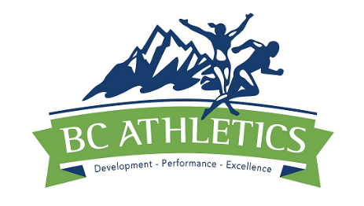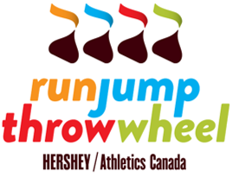

2017 BC Athletics Summer Student Employment Opportunity
Run Jump Throw Wheel, Coaches/Officials Program Assistant
(Supported by: The Canada Summer Jobs Program - Government of Canada and BC Athletics)

Job Position: Run Jump Throw Wheel, Coaches/Officials Program Assistant

Estimated Length of Employment: 14 to 15 weeks
Starting Date: Monday, May 22, 2017 Ending Date: Friday, August 25 or Friday, September 1, 2017

Application Deadline: Monday, May 15, 2107 – 4:00pm.

Program (Federal Govt) requirements for all applicants:
- be between 15 and 30 years of age at the start of the employment;
- have been registered as a full-time post-secondary student in the academic year (2016/17) and intending
to enroll or return to post-secondary school on a full-time basis in the academic year (2017/18);
- be a Canadian citizen, permanent resident or persons on whom refugee protection has been conferred under
the Immigration and Refugee Protection Act;
- be legally entitled to work in Canada in accordance with relevant provincial/territorial legislation and
regulations; and
- not be a family member or related to members of the BC Athletics Board of Directors or Staff.

Job Responsibilities:
Run Jump Throw Wheel, Coaches/Officials Program Assistant
I. Working with BC Athletics Staff responsible for these programs, the summer student will:
1. Direct delivery of the Run Jump Throw Prog to Children/Yth.
2. Assist in the delivery of Instructor Trng courses.
3. Managing the database of Run/Jump/Throw participants & trained instructors.
4. Review & updating the RJT materials/AV aids for courses & Prog promotion.
5. Planning, coordination & delivery of BC Athletics RJTW/Track Rascals Summer Camps.
6. Coach Education - assist in planning and preparation & delivery of Trng courses including the
direct delivery to First Nations Coaches.
7. Plan, coordinate and assist in the delivery of summer professional development opportunities
for coaches at Club, BC Championships and International competitions in BC.
9. Obtain feedback from coaches and develop a plan for online professional development
for coaches thru: seminars, webcasts, video logs and other as may be identified.
10. Officials Development - With BC Athletics Staff and the Officials Committee assist in the
planning, preparation and delivery for the Recruitment and Training of new Officials.
11. Assist in organizing Officials seminars associated with International competitions and
Provincial Championships held in British Columbia.
12. Providing assistance in the collection and reporting of information on Officials Clinics,
Recruitment initiatives and Participation in mentoring and upgrading.

Hours per Day/Week: 7 hrs per day / 35 hrs per week / 14 to 15 week duration Salary: $16.00 per hr.

Job Location: BC Athletics Office, Fortius Athlete Development Centre,
3713 Kensington Ave, Ste 2001-B, Burnaby, BC V5B 0A7

Requirements and Preferred/Beneficial Skills:
- Applicants must be enrolled in a Post-Secondary School and planning to return for the 2017 Fall Term.
- Self-starting/initiating, organized individual with problem solving capabilities
- Experience in sport as a participant, organizer or event volunteer
- Event promotion, marketing and sponsorship experience an asset
- Childhood movement/skill development knowledge, training or experience is an asset
- Education/Training in Physical Education, Human Kinetics, Long Term Athlete Development,
Sport for Life, Run Jump Throw Wheel/Track Rascals and the BC Athletics Junior Development Programs.
- Knowledge/experience with: Word Processing; Spreadsheets; Web posting; other software
- Experience in effective use of Social Media
- Experience in working with volunteers
- Good writing and speaking skills plus a sense of humor
- Previous work experience

This position may involve: a) travel in the Lower Mainland and elsewhere in BC - driver’s license and access to a vehicle may be needed; b) may also require lifting and set up of various materials.

BC Athletics is an equal opportunity employer and encourages applications from all qualified individuals.

Application Process: Please submit a covering letter of application along with a resume and 3 references to:
BC Athletics, Attn: Brian McCalder, 3713 Kensington Avenue, Ste 2001-B, Burnaby, BC V5B 0A7
Fax: 604-333-3551 Email: brian.mccalder@bcathletics.org Application Deadline: Monday, May 22 - 4 pm

