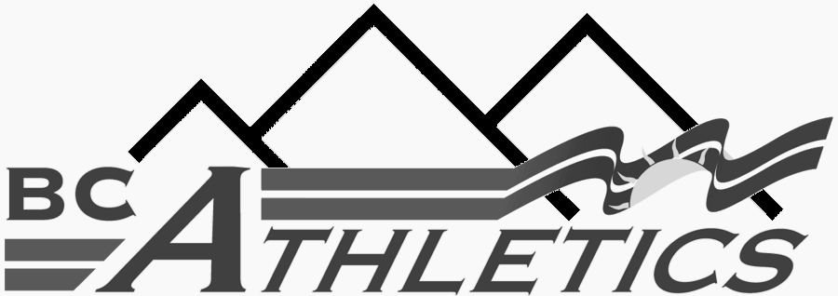 | BC Athletics Branch Officials Course Registration Form  To complete “on-line”: To complete form manually:  Save form to your computer Print form  Complete Complete  Email to sam.collier@bcathletics.org Fax to (604) 333-3551 or mail to BCA | A BCA Branch Officials Course Registration Form must be completed for ALL Officials Courses and/or  Clinics. The completed form is to be submitted to the BC Athletics office.  Date : _________ Course Registrar : __________________________  Location : ____________________ Email : ________________________________  Course Level : _____________

1 Gender :  M = Male  F - Female |  | 2 Education Level :  S = Secondary  C = College  U = University |  | 3 Federal Program Status:  F = First Nations descent  C = Canadian Forces  R= RCMP |  | 4 BC Athletics Affiliation:  U = Unattached  C = BCA Club  N = Not a BCA member |  | 5 Fee receipt required?  Y – Yes – must provide an email address  N = No

BCA Number | 1 | Surname | First Name | Street | City | Prov. | Postal Code | Zone | Telephone # | Birth Date  DD/MM/YYYY | 2 | 3 | 4 | 5 | E-mail

1.

2.

3.

4.

5.

6.

7.

8.

9.

10.

1 Gender :  M = Male  F - Female |  | 2 Education Level :  S = Secondary  C = College  U = University |  | 3 Federal Program Status:  F = First Nations descent  C = Canadian Forces  R= RCMP |  | 4 BC Atheltics Affiliation:  U = Unattached  C = BCA Club  N = Not a BCA member |  | 5 Fee receipt required?  Y – Yes – must provide an email address  N = No

BCA Number | 1 | Surname | First Name | Street | City | Prov. | Postal Code | Zone | Telephone #  ( ) | Birth Date  DD/MM/YYYY | 2 | 3 | 4 | 5 | E-mail

11.

12.

13.

14.

15.

16.

17.

18.

19.

20.

21.

22.

23.

24.

25.

26.

27.

